**DAILY ONLINE ACTIVITIES SUMMARY**

|  |  |  |  |  |  |  |  |  |
| --- | --- | --- | --- | --- | --- | --- | --- | --- |
| **Date:** | **19-6-2020** | | | | | **Name:** | **Prajna** | |
| **Sem & Sec** | **8th sem ‘B’** | | | | | **USN:** | **4AL16CS067** | |
| **Online Test Summary** | | | | | | | | |
| **Subject** | | **BDA** | | | | | | |
| **Max. Marks** | | **30** | | **Score** | | | **20** | |
| **Certification Course Summary** | | | | | | | | |
| **Course** | **Introduction to python programming** | | | | | | | |
| **Certificate Provider** | | | **Great learning** | | **Duration** | | | **2hrs** |
| **Coding Challenges** | | | | | | | | |
| **Problem Statement:**1**.** Write a c program to remove characters except alphabets in string. | | | | | | | | |
| **Status: Completed** | | | | | | | | |
| **Uploaded the report in GitHub**  **GitHub link:** | | | | | **Yes**  **https://github.com/alvas-education-foundation/prajna_k** | | | |
| **If yes Repository name** | | | | | **prajna_k** | | | |
| **Uploaded the report in slack** | | | | | **yes** | | | |

Online Test Details: (Attach the snapshot and briefly write the report for the same)

Certification Course Details: (Attach the snapshot and briefly write the report for the same)

Coding Challenges Details: (Attach the snapshot and briefly write the report for the same)

1)online test

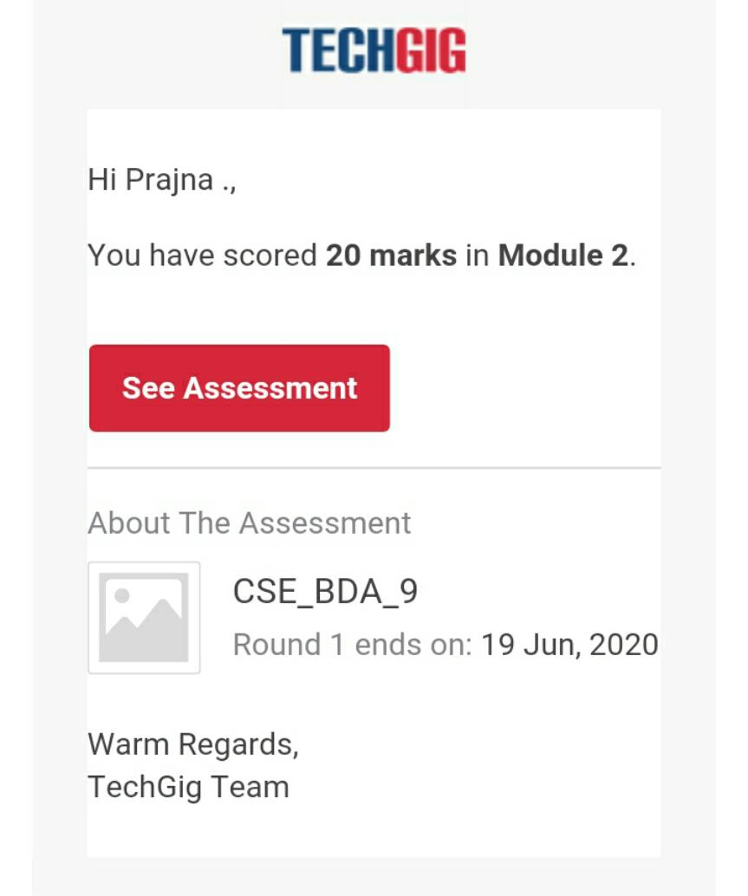

2) certification course

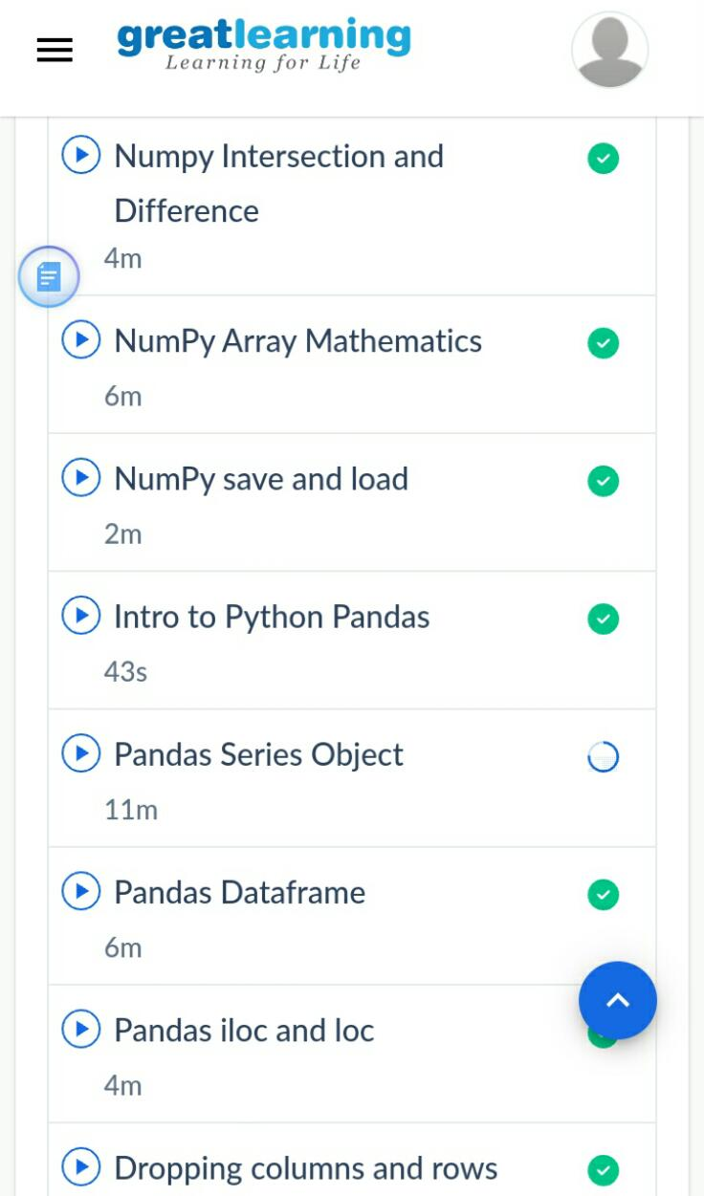

3) coding challenges

#include <stdio.h>

#include <string.h>

void main(){

char str[150];

int i,j;

printf("\n\nRemove characters in String Except Alphabets :\n");

printf("--------------------------------------------------\n");

printf("Input the string : ");

fgets(str,sizeof str,stdin);

for(i=0; str[i]!='\0'; ++i)

{

while (!((str[i]>='a'&&str[i]<='z') || (str[i]>='A'&&str[i]<='Z' || str[i]=='\0')))

{

for(j=i;str[j]!='\0';++j)

{

str[j]=str[j+1];

}

str[j]='\0';

}

}

printf("After removing the Output String : %s\n\n",str);

}

|  |
| --- |
|  |
|  |  |
|  |  |
|  |  |
|  |  |
|  |  |